Create new project using command prompt

1. npm init
2. 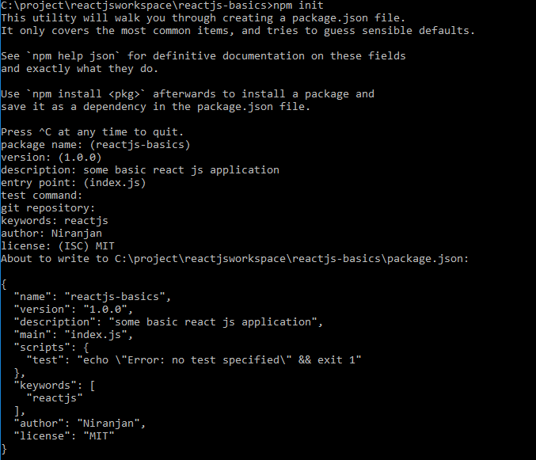
3. npm install react react-dom –save
4. npm install webpack webpack-dev-server babel-loader babel-preset-es2015 babel-preset-react babel-preset-stage-2 --save-dev
5. npm install babel-preset-env --save-dev

**Webconfig for windows**

<https://gist.github.com/flyingzl/42e61de92490219f2c48>

<https://webpack.js.org/configuration/>

<https://github.com/facebook/create-react-app>

<https://github.com/coreybutler/nvm-windows#node-version-manager-nvm-for-windows>

npm i react-dev-utils

<https://github.com/AmitKRSaha/ReactPractice>

<http://babeljs.io/repl>

npm init react-app my-app